**SHOOT THE BIRD**

Team Octans

JavaScript Basics – Team Project Assignment

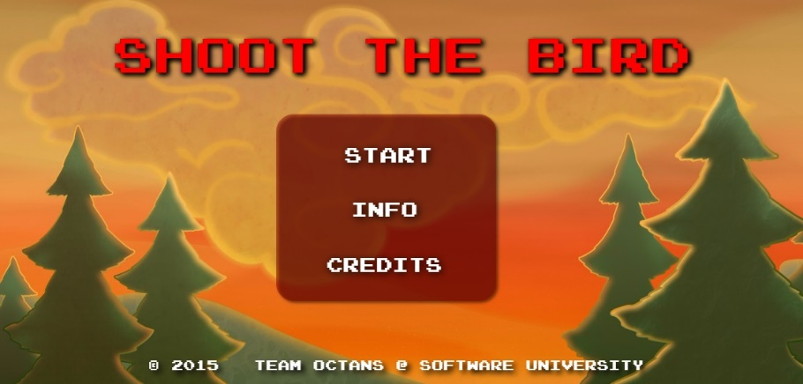

Source: [GitHub page](https://github.com/Team-Octans/JavaScript-Basics-Teamwork-Assignment)

Webpage: <http://octans.tk>

Language used: JavaScript

Framework used: [CreateJS](http://createjs.com/) - 2014.12.12

IDEs used: WebStorm, Sublime Text

Tested on: Firefox, Chrome, Internet Explorer

The invasion is looming… Annoying blue birds are threating your way of life and everything you hold dear. Only you can stop them – you and your precious GUN!

You created an intelligent function that tracks your score. Each bullet costs money though so the function will punish you if you miss.

The birds will also quickly realize that the Savior of the Forest is onto them – they will fly faster with each kill.

Your chamber holds six bullets. You cannot reload until it is empty, so keeping track of the bullets is of vital importance.

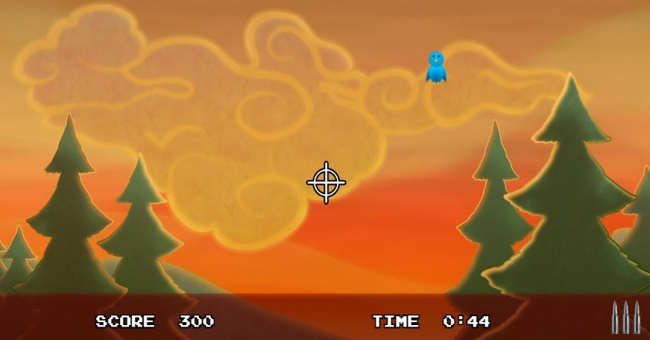

Now go and kill some birds!!!